Crusaders Cup Final
(Monday 12th April 2010)

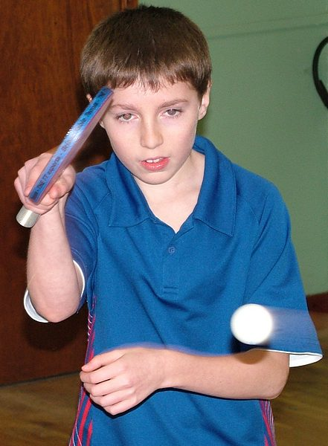
Jamie Hughes

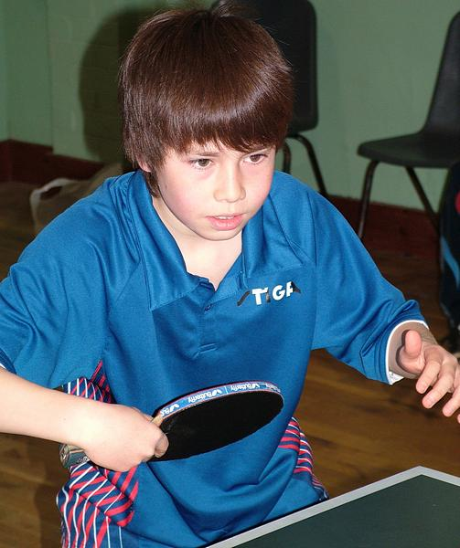
Liam Grant
LIAM LEADS TEAM TO CUP FINAL VICTORY
10 year old Liam Grant from Wallington took his team to victory in an all-Crusaders cup final of the Sutton & District Table Tennis League on Monday night (12/4/10). Liam teamed up with Kingswood�s 12 year old Jamie Hughes and Wallington�s Joseph Yee for their 5-2 win.
The boys were playing against their friends and rivals Krishan Sareen, Alex Yee and Alex Rolls. Before an enthralled 50-strong audience the oldest player on view was just 14 years old. The average age of Sutton Leagues players is about three or four times this! Liam beat all three of his opponents while Jamie and Joseph chipped in with one win out of two each. International Umpire Margot Fraser officiated.
Liam and Jamie have both recently qualified to play in the National Championships to be held in Doncaster next month. Jamie finished 3rd among 9 players in the under 12's event while Liam beat all 8 of his opponents in the U11�s category of the regional trials.
Michael Loveder

